## **Step 1 Project Overview**

Design and implement a single screen app that displays information about a fictional small business. Think along the lines of your favorite coffeeshop, local restaurant, or that gem of a store that sells those rare comic books or records.

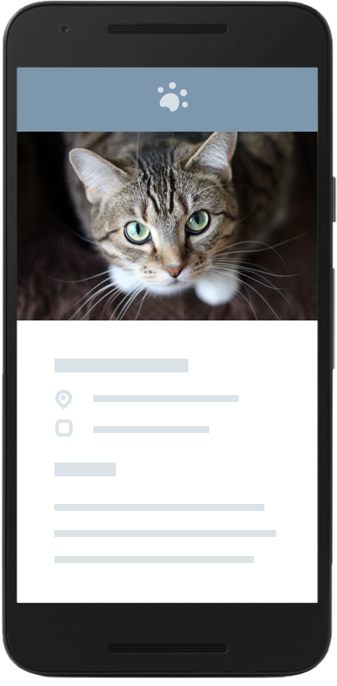

### **Suggested App Ideas**

* Details about a small business in your neighborhood
* Contact info and description about your workplace or school
* Info about a special interest group (like a club or sports team) you’re part of and how new members can sign up

### **Requirements**

Your design must include:

* At least one photo representing the business
* Business Name
* Phone number or email address for the business
* Address of the Business

*Optional components*

* Website for the business
* Hours of operation

Note: This is not required but If you’re up for a making real impact in your community, go check out an actual local business and obtain their consent to build an app for them!

**Step 2:**

## **Build Your Project**

### **Create an XML document**

To complete this project, you will need to create an XML document. We encourage you to use Android Studio to complete this part of the project, as it has auto-complete features for creating XML tags.

### **Include a ViewGroup**

Be sure to include a ViewGroup (RelativeLayout or LinearLayout) and enough views (Image, Text, or Button views) to complete the project. Check your project against the rubric linked on the next page.

**Step 3:**

## **Prepare for Submission**

### **Clean your Build**

Before submitting, please follow the instructions for cleaning your project files. This removes some temporary files and greatly decreases the size of your project.

[Cleaning Your Project Files](https://d17h27t6h515a5.cloudfront.net/topher/2016/June/5769c116_1000-files-tutorial/1000-files-tutorial.pdf)

### **Review the Project Rubric**

Udacity reviewers will be reviewing your project based on the project rubric. All specifications must be met to pass the project.

[Project Review Rubric](https://review.udacity.com/?_ga=1.202311889.1362034947.1463828731#!/rubrics/133/view)

### **Final Submission Checklist**

Before submitting your project for evaluation, we recommend that you check that each of the following is true:

1. Your app compiles and runs as expected.
2. You are proud of your app and its output.
3. You completed this project according to instructions.
4. You cleaned the project using the instructions above.
5. You checked your project against the rubric.

### **Zip your Project for Submission**

Be sure to zip your whole android project only after you have cleaned it.